SWE 206

LAB 1

**Lab topic: Introduction**

**Section No: 52**

**Groups members:**

**Ahmed Almakhlooq 202017740**

**Ridah Al-Moslem 202017940**

**Requirements:**

**- The program should generate groups with random students.**

**- Create groups with a specific size.**

**- Create specific numbers of groups.**

**- Add the rest of the students to a randomly chosen group.**

**Design:**

**- Initialize an empty ArratList to have the names.**

**- Read the file and add it to the ArrayList.**

**- Create a 'fixedSizeGroups' method that has our**

**'ArrayList' and the size of each group as an argument.**

**- Create a 'fixedNumberGroups' method that has our**

**'ArrayList' and the number of groups as an argument.**

**Testing:**

**choice 1: creating a specific number of groups.**

**choice 2: creating groups with a fixed number of students.**

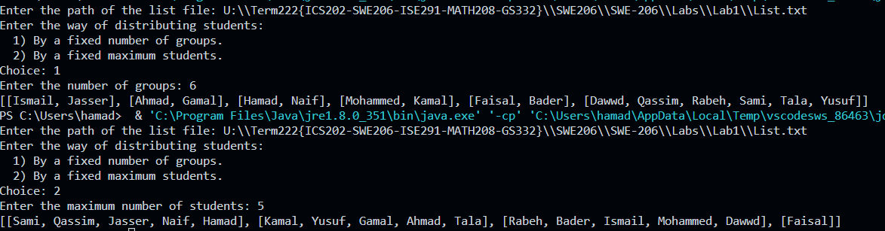

**Implementation:**

**Main method:**

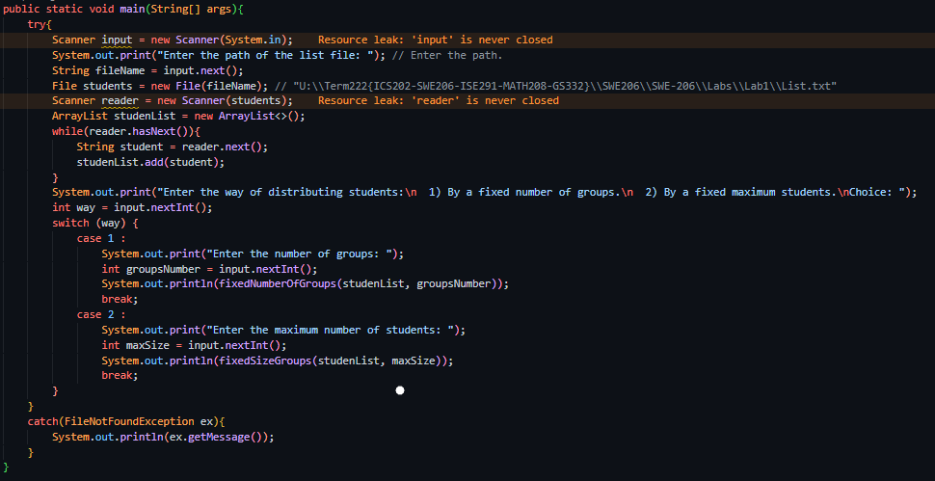

**fixedSizeGroups method:**

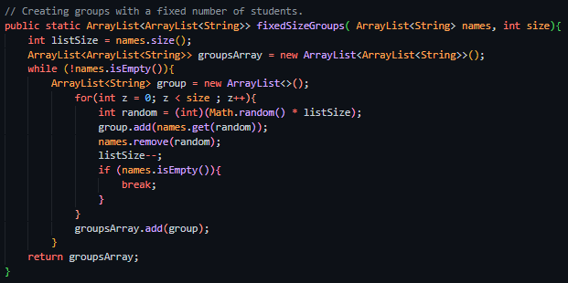

**fixedNumberOfGroups method:**

